**Exercise 1: Mocking and Stubbing**

**Scenario:**

You need to test a service that depends on an external API. Use Mockito to mock the external API and stub its methods.

Steps:

1. Create a mock object for the external API.

2. Stub the methods to return predefined values.

3. Write a test case that uses the mock object.

**Solution:**

**pom.xml**

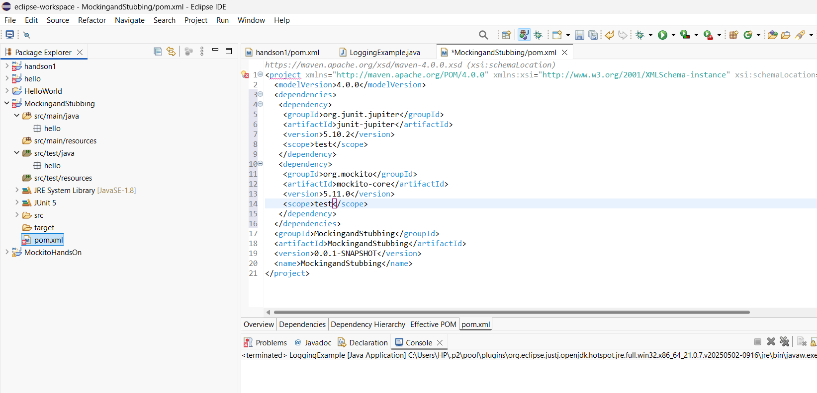

***ExternalApi:***

package hello;

public interface ExternalApi {

String getData();

}

***MyService:***

package hello;

public class MyService {

private ExternalApi api;

public MyService(ExternalApi api) {

this.api = api;

}

public String fetchData() {

return api.getData();

}

}

***MyServiceTest:***

package hello;

import static org.junit.jupiter.api.Assertions.*assertEquals*;

import static org.mockito.Mockito.*;

import org.junit.jupiter.api.Test;

public class MyServiceTest {

@Test

public void testExternalApi() {

ExternalApi mockApi = *mock*(ExternalApi.class);

*when*(mockApi.getData()).thenReturn("Mock Data");

MyService service = new MyService(mockApi);

String result = service.fetchData();

*assertEquals*("Mock Data", result);

}

}

